МІНІСТЕРСТВО ОСВІТИ І НАУКИ УКРАЇНИ

ХАРКІВСКИЙ НАЦІОНАЛЬНИЙ ЕКОНОМІЧНИЙ УНІВЕРСИТЕТ

ІМЕНИ СЕМЕНА КУЗНЕЦЯ

Лабораторна робота №6

Тема: «Packet tracer - Implementing basic connectivity»

з дисципліни «Введення в мережі»

Виконав:

Студент групи 6.04.125.010.21.2

факультету Інформаційних технологій

спеціальності 125

П.І.П. Бойко В.В.

Перевірив:

Леуненко О.В.

Харків – 2022

Part 0

I have added 2 PCs and 2 switches

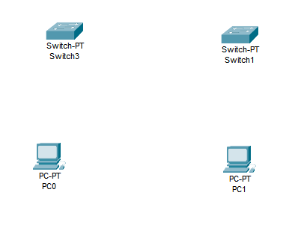

I have connected it with cabels

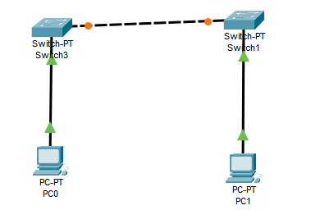

Part 1

Step 1

I have opened “Switch 3” and chose CLI tab

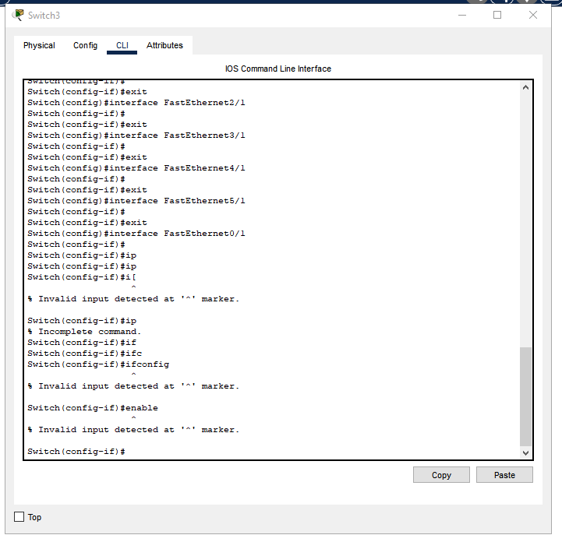

I have typed command “hostname S1”

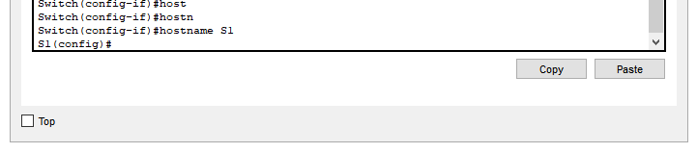

Step 2

I have typed command “line console 0” for configuring console

With command “password cisco” I have set password as “cisco”

With next two commands I have logged in and logged out

“login” and “exit”

I have set “class” as privilege mode password

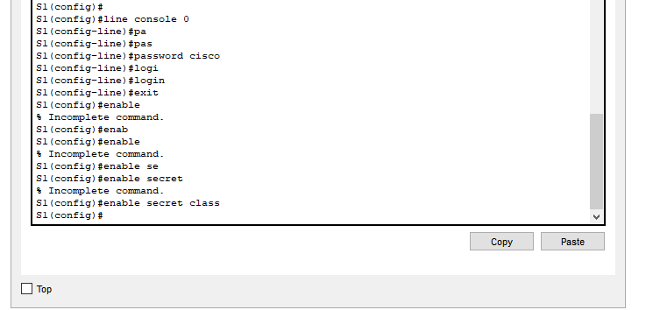

Step 3

For verifying I have exit form config mode with command “exit”

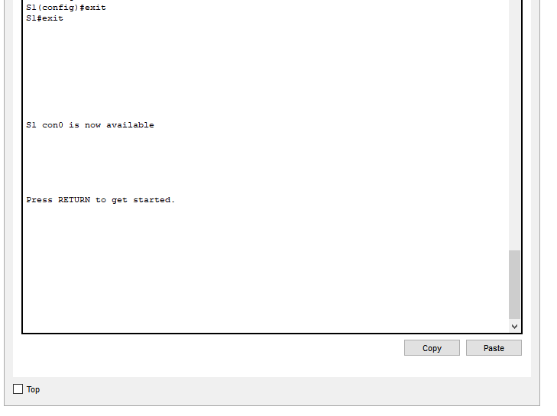

I have pressed “Return” button and the password was answered

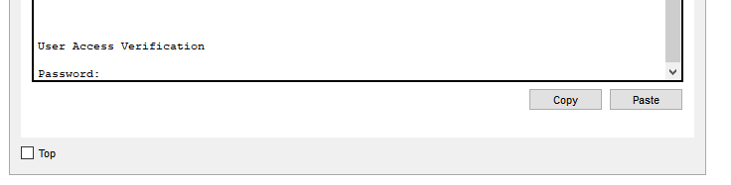

First try was not success, because password was not “cisco”

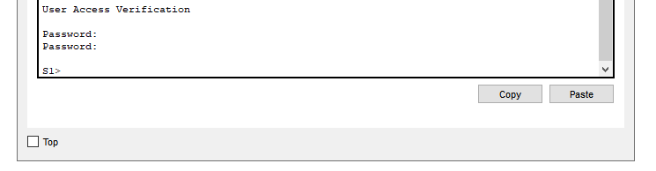

First try was not success, because password was not “class”

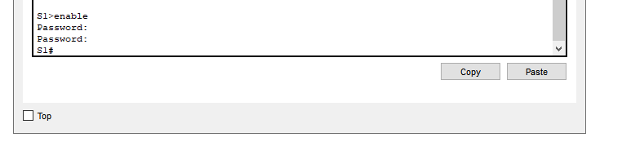

Step 4

I have opened config mode for terminal and I have added banner

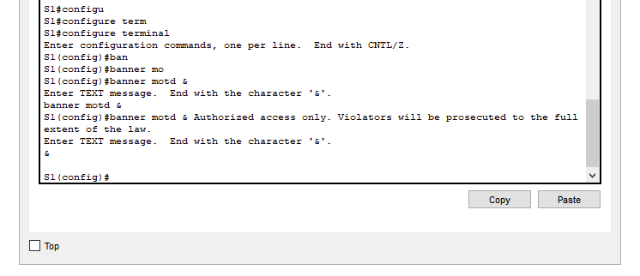

Step 5

I have saved the config file for S1

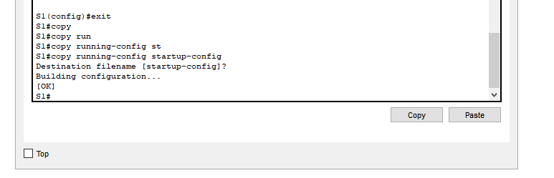

Step 6

I did the same for S2

I have renamed switches in visual mode

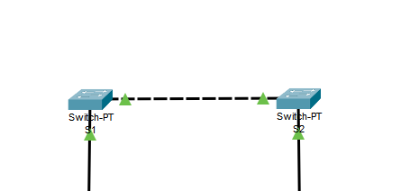

Part 2

Preparation

I have renamed PCs in view mode

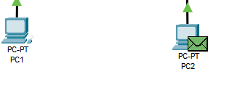

Step 1

A have opened PC 1 with double click

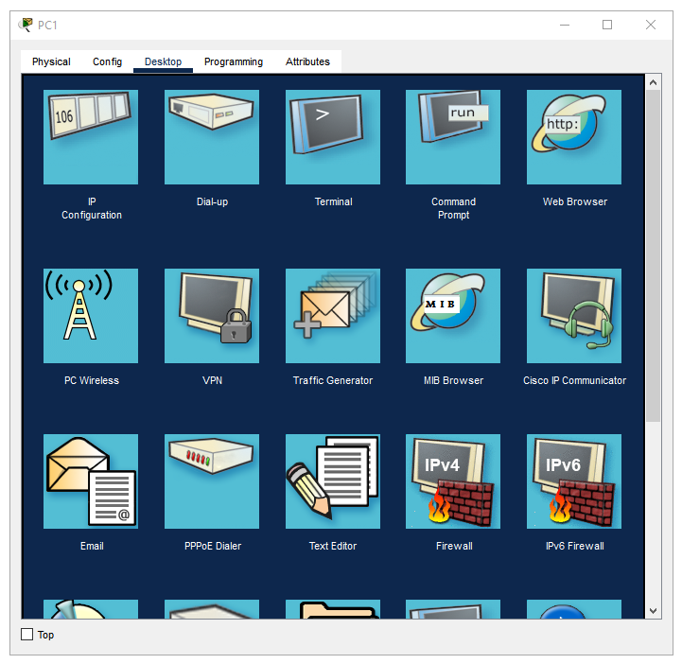

In the opened window I chosen “ip configuration”

And I have typed “192.168.1.1” to IPv4 Address and “255.255.255.0” to the Subnet Mask

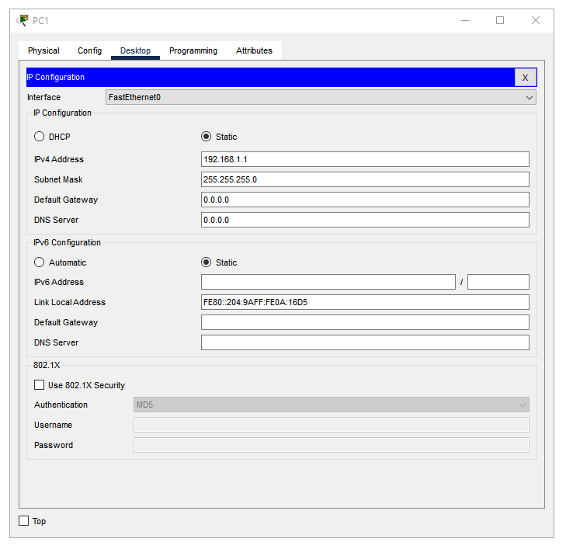

I did the same for PC 2, but with different IP address

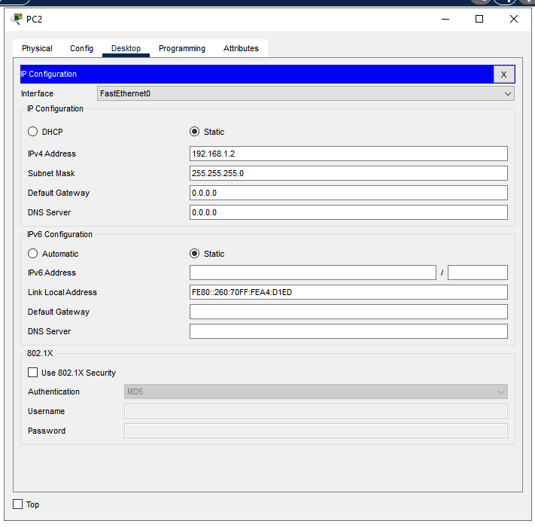

Step 2

I have opened PC 1 with double click, in the opened window I chose “Desktop” tab and “Command Prompt” program

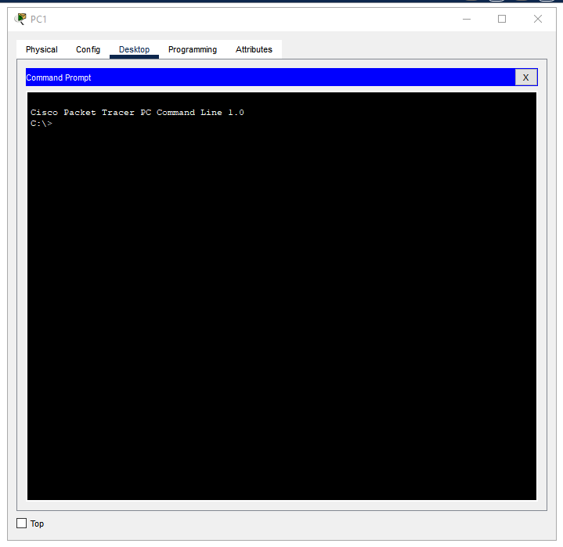

In the opened window I have type ping “192.168.1.253”

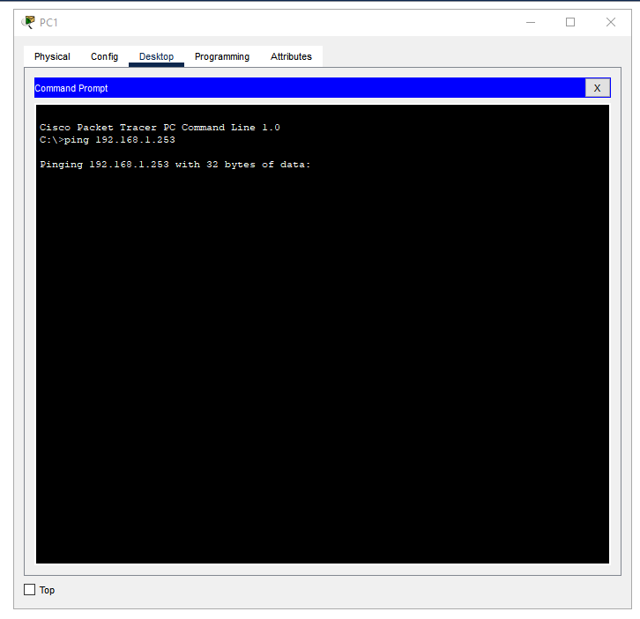

Not success, because switches was not seted

Part 3

Step 1

I have opened CLI on S1 and I have typed following command “ip address 192.168.1.253 255.255.255.0”

Not success



I have logged out, logged in enable privileged mode, opened configuration

Type “int vlan 1” for configuring

And set ip address

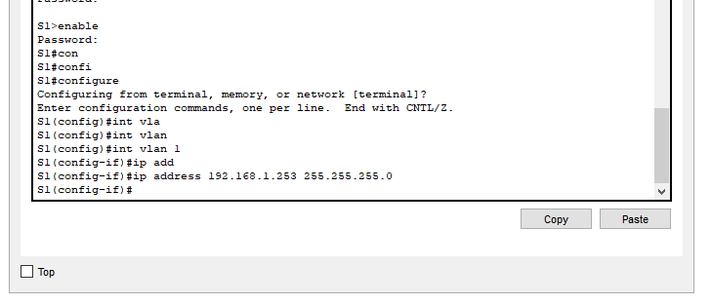

Step 2

Do the same for switch 2

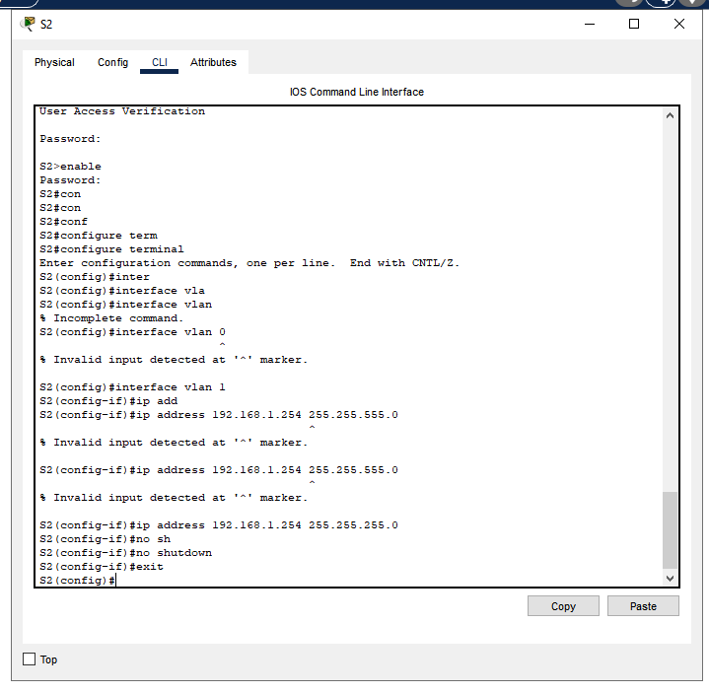

Step 3

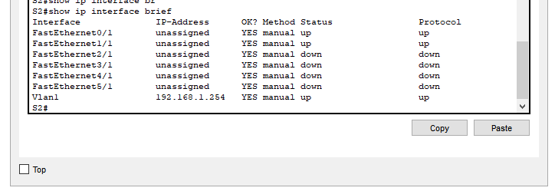

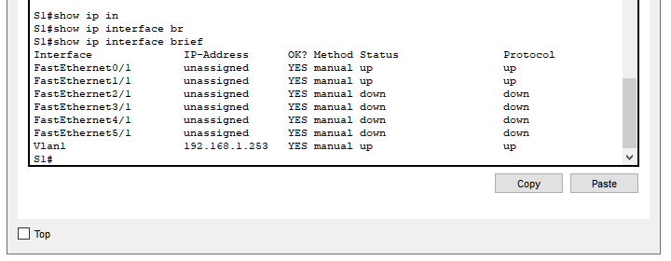

Step 4

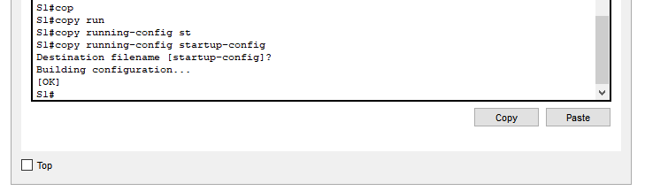

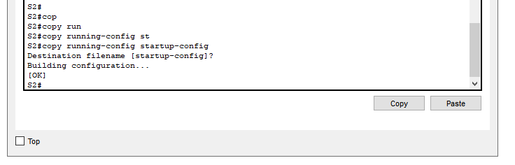

Step 5

I have opened PC1 and chose “Desktop” tab

In the desktop tab, I have opened ‘Command prompt’

And with ping command I have tried to have access to PC2 by ip address

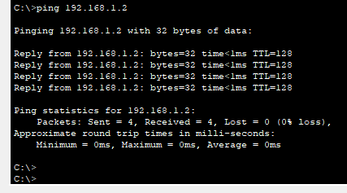

Connection exists

Check for connection between PC1 and S2 by IP

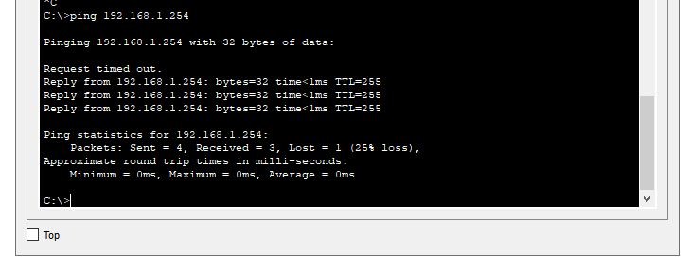

Check for connection between PC1 and S1 by IP

